DBMS Practical No.: 16

**Name: yash ajay magar**

**Experiment No 16: Implement SQL queries for Inner and Outer Join**

Exercise:

1. Display employee Nikhil’s employee number, name, department number, and department location.

2. Display the list of employees who work in the sales department.

3. Display the list of employees who do not work in the sales department.

4. Display the employee names and salary of all employees who report to Sumit Patil.

1. Display employee Nikhil’s employee number, name, department number, and department location.

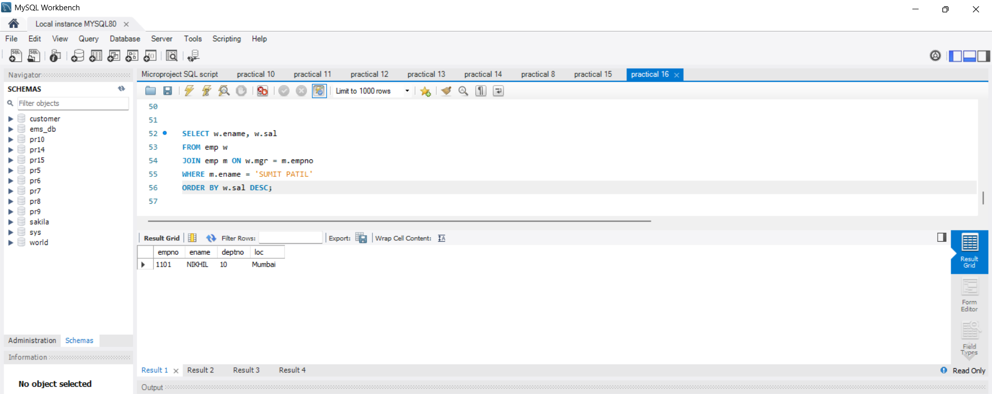

2. Display the list of employees who work in the sales department.

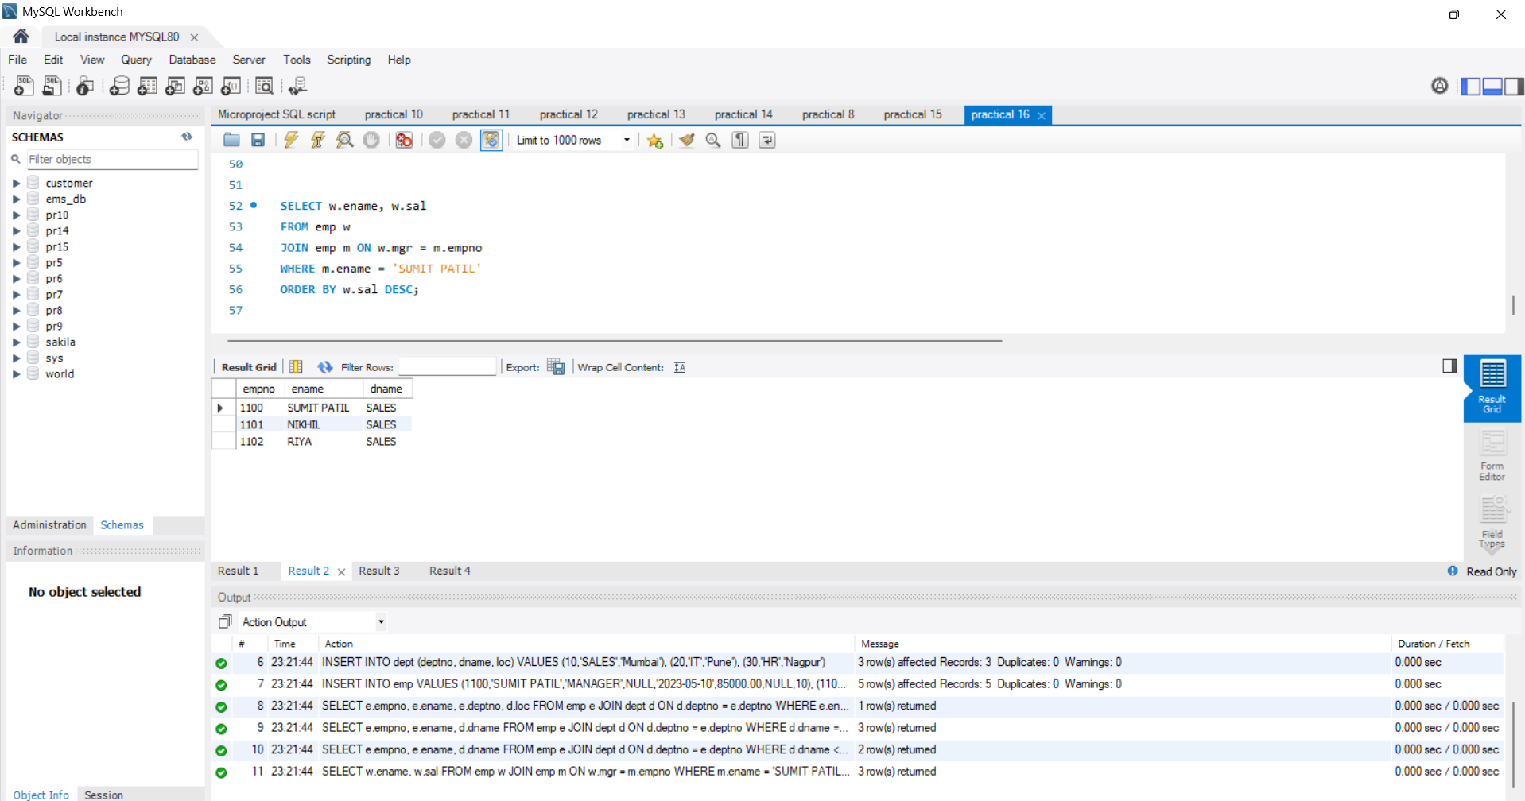

3. Display the list of employees who do not work in the sales department.

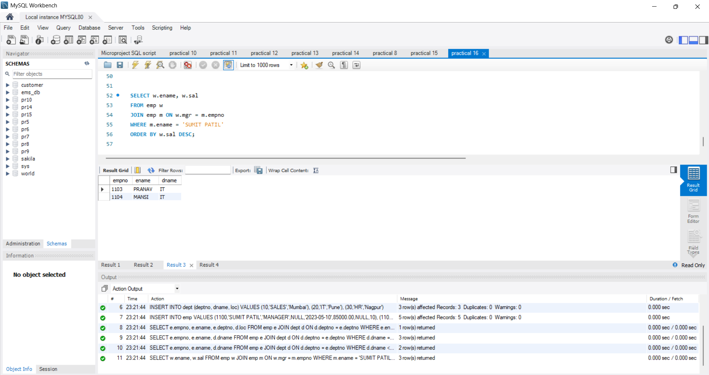

4. Display the employee names and salary of all employees who report to Sumit Patil.

